Tire Basics Chapter 2 Review
- The service description found on the sidewall identifies the tire’s speed rating and load index. Using the example tire, 225/45R17 94W, identify the speed rating and load index of the tire.

- The load range of a light truck tire identifies how much load the tire is designed to carry at its specified air pressure. What is the difference in construction plies, and the maximum air pressure between a load range D tire, and a load range E tire?

- What does the ‘M&S’ found on the sidewall of certain tires mean?

- What does the symbol below that can be found on the sidewall of the tire mean?


- The size of the flotation tire pictured below is 33X12.5R15. Fill in the blanks to identify each measure of the tire size.
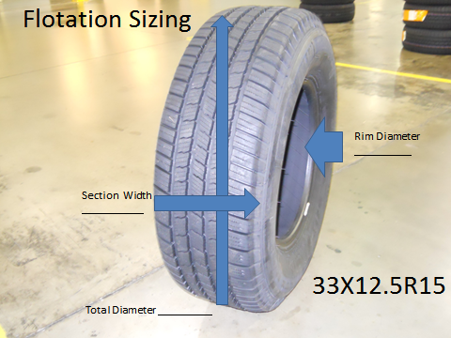

- What characteristics of a tire do sidewall markings like N1, MO, B1, or J describe?

- Looking at the tread design pictured below, is the tread pattern of this tire directional, symmetrical, or asymmetrical? (1 bonus point for correctly identifying the brand and model of the tire).
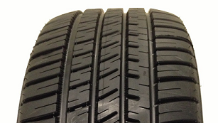

- Looking at the tread design pictured below, is the tread pattern of this tire directional, symmetrical, or asymmetrical? (1 bonus point for correctly identifying the brand and model of the tire).
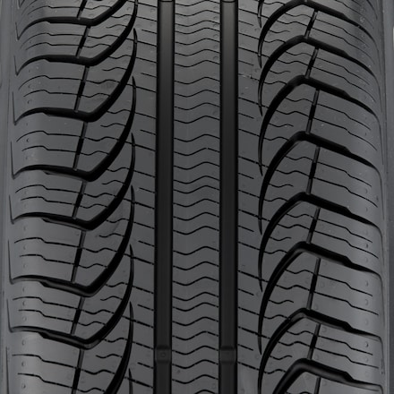
- Use the Tire Rack part numbers listed below to describe as much as possible about each tire (complete size, speed rating, brand and/or model, extra sidewall descriptions)

  - 055TR6WS70
  - 445YR8ECDWSXL
  - 86HR4FZTOUR
  - 475QR7WDTOWL
  - 95HR5EAST

- Using the Tire Rack brand abbreviations below, determine the brand of tire described in each abbreviation.
  - PI- .
  - FZ- .
  - BF- .
  - GE- .
  - MI- .

- Using the list of sidewall descriptions below, match each picture with the correct sidewall description
