Tire Basics Chapter 2 Review
- The service description found on the sidewall identifies the tire’s speed rating and load index. Using the example tire, 225/45R17 94W, identify the speed rating and load index of the tire.
Speed rating = W
Load Index = 94

- The load range of a light truck tire identifies how much load the tire is designed to carry at its specified air pressure. What is the difference in construction plies, and the maximum air pressure between a load range D tire, and a load range E tire?
Difference between D and E in construction plies = 2 (plies = how many layers of steel, nylon, polyester etc underneath the tread. The more plies the heavier and thicker the tire and more air pressure a tire can hold)
D = 8 plies = 65 PSI
E= 10 plies= 80 PSI
On a shipping label you may see all 3 of these mixed (E, 10 plie or 80 PSI) they all mean the same thing much like a run flat in having a few different ways to say it.

- What does the ‘M&S’ found on the sidewall of certain tires mean?
Mud and Snow
- What does the symbol below that can be found on the sidewall of the tire mean?
 Severe snow designation (meaning only to used as snow tire)

- The size of the flotation tire pictured below is 33X12.5R15. Fill in the blanks to identify each measure of the tire size.

Total Diameter = 33
Section Width= 12.5
Rim Diameter= 15
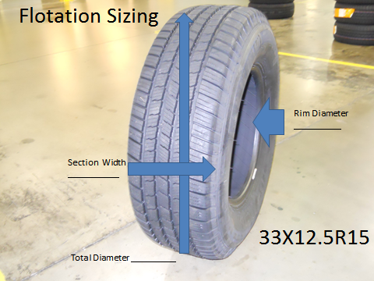

- What characteristics of a tire do sidewall markings like N1, MO, B1, OR J describe?
OE (original Equipment) Tire
Basically the stock tire that came on the vehicle from the factory
N1 = Porsche
MO= Mercedes
B1= Bentley
J= Jaguar

- Looking at the tread design pictured below, is the tread pattern of this tire directional, symmetrical, or asymmetrical? (1 bonus point for correctly identifying the brand and model of the tire).
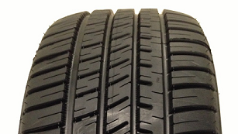
Asymmetrical ( Michelin Pilot Sport AS 3) I haven’t seen this tire in a long time so I don’t know if we carry it anymore

- Looking at the tread design pictured below, is the tread pattern of this tire directional, symmetrical, or asymmetrical? (1 bonus point for correctly identifying the brand and model of the tire).
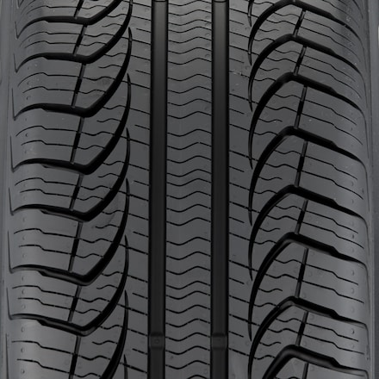 Symmetrical Tire (Pirelli P4 Four Seasons)

- Use the Tire Rack part numbers listed below to describe as much as possible about each tire (complete size, speed rating, brand and/or model, extra sidewall descriptions)

  - 055TR6WS70 - 205/55/16 Bridgestone Blizzak WS70 T speed rating
  - 445YR8ECDWSXL – 245/45/18 Conti Extreme Contact DWS Extra Load Y speed rating
  - 86HR4FZTOUR – 185/60/14 Fuzion Touring H speed rating
  - 475QR7WDTOWL 245/75/17 GoodYear Wrangler Duratrac Outlined White Letter Q speed rating
  - 95HR5EAST – 195/50/15 Kumho Ecsta AST H speed rating

- Using the Tire Rack brand abbreviations below, determine the brand of tire described in each abbreviation.
  - PI- Pirelli .
  - FZ- Fuzion .
  - BF- BF Goodrich .
  - GE- General .
  - MI- Michelin .

- Using the list of sidewall descriptions below, match each picture with the correct sidewall description
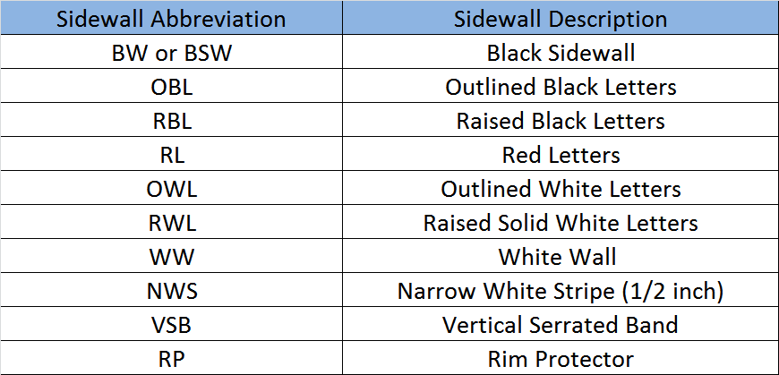

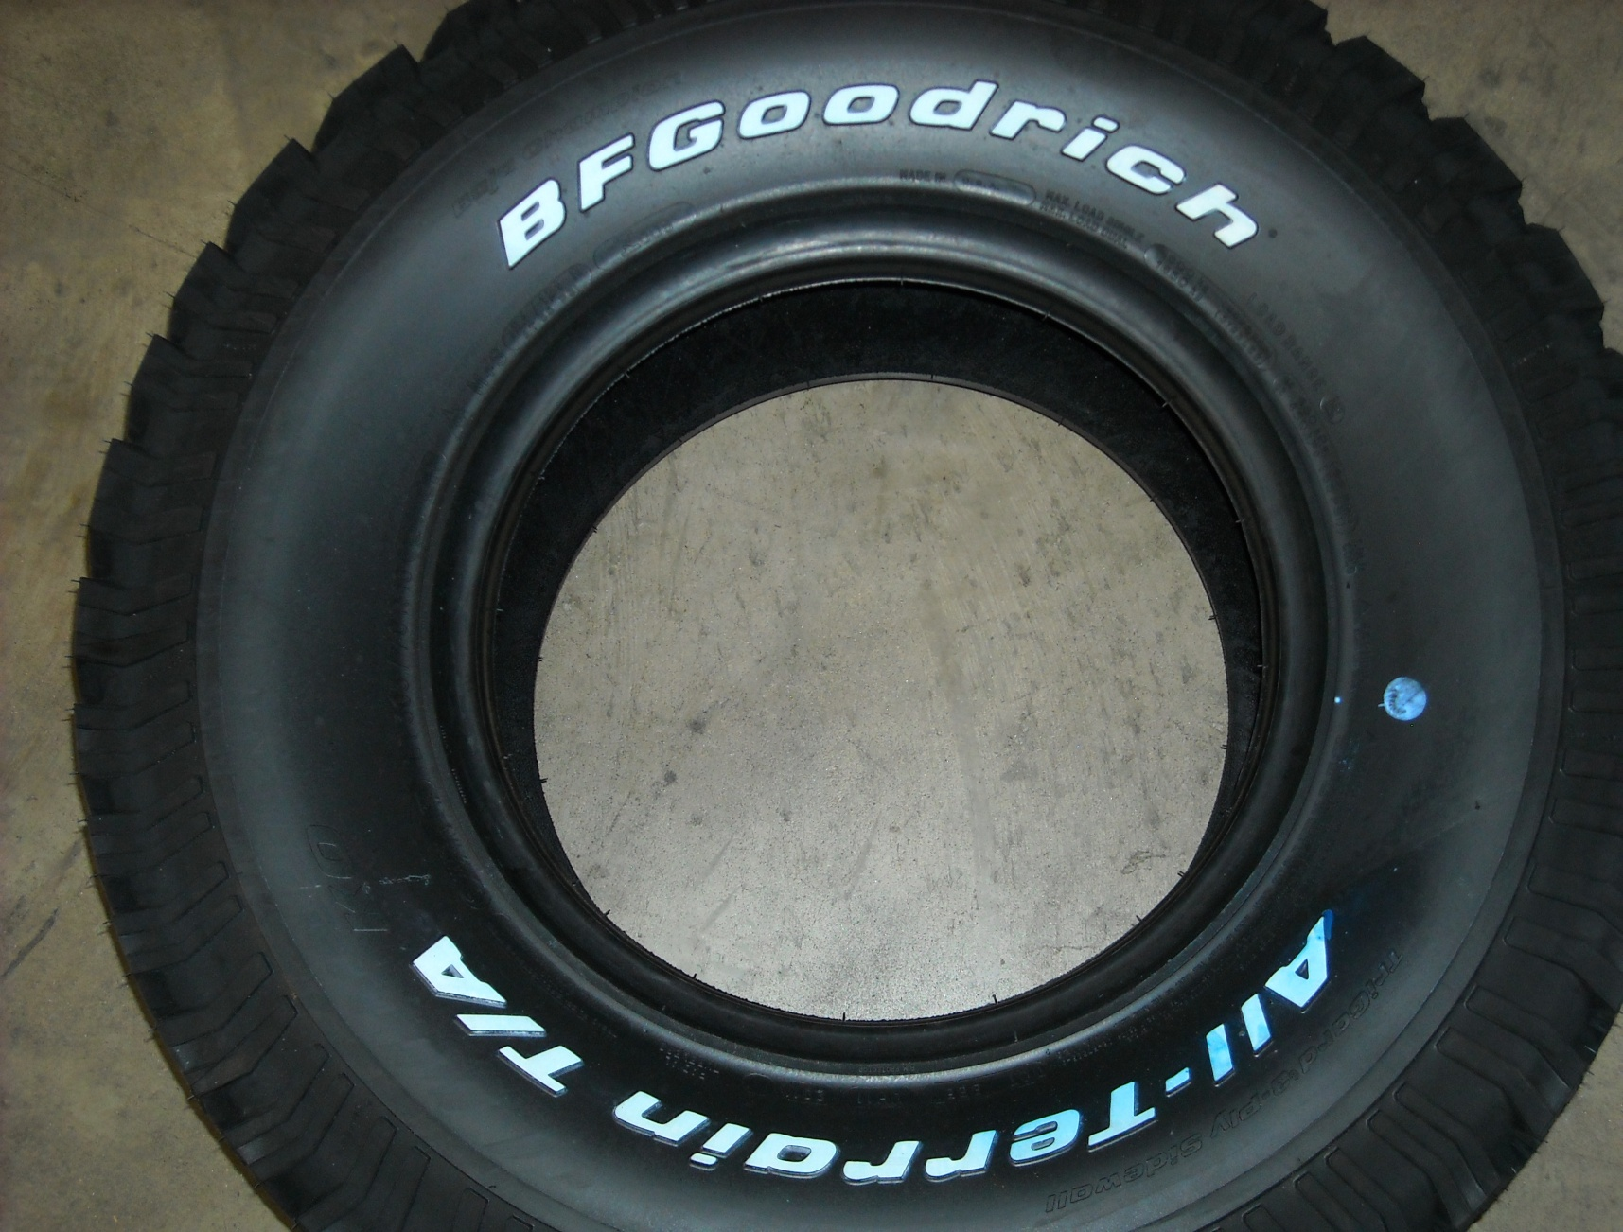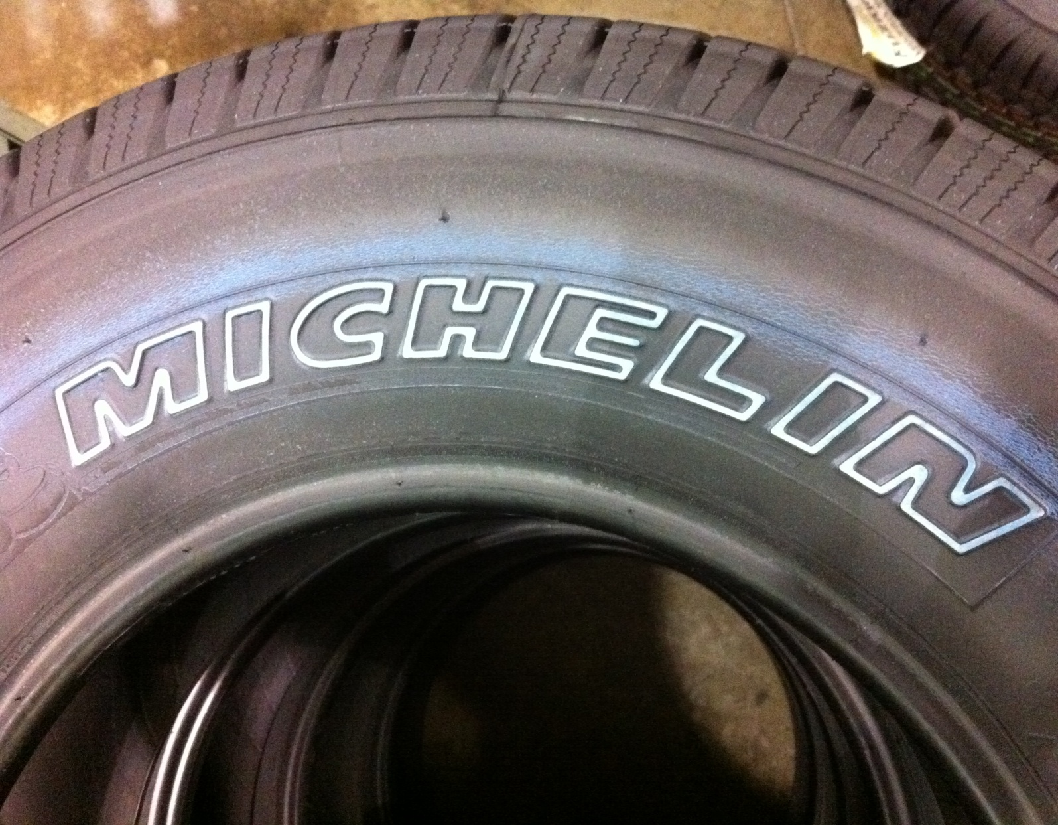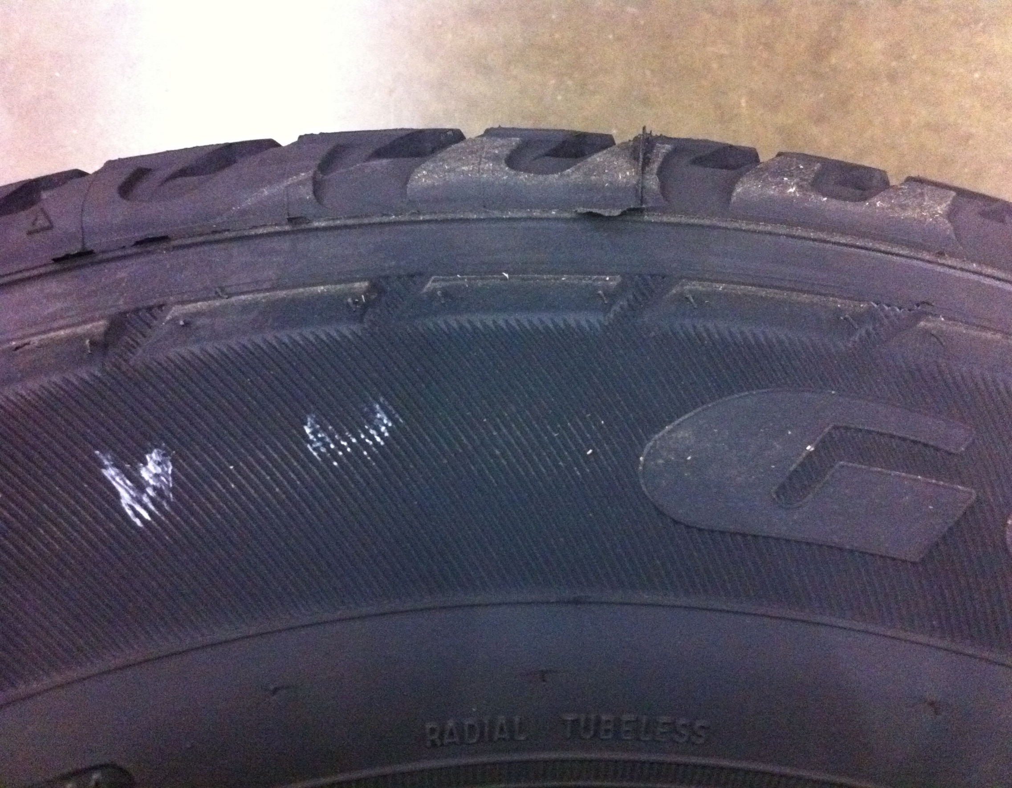
RWL OWL VSB

