Tire Basics Chapter 1 Answers
- Identify each component of the tire pictured: Tread, bead, and sidewall.
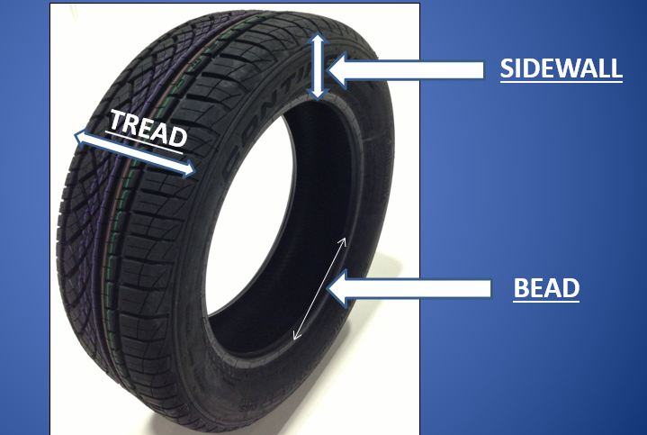
2. The picture below features 3 tires with different section widths; 295, 195, and 235. Please identify the section width of each tire.
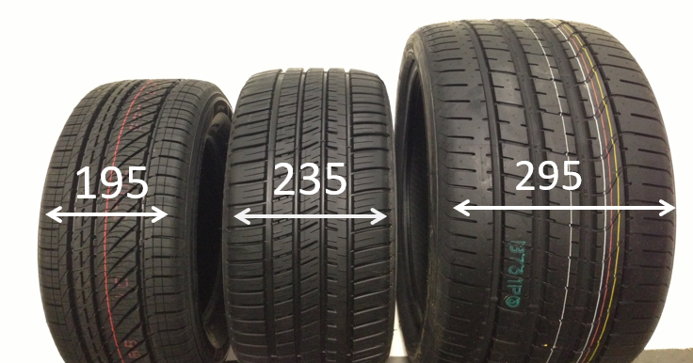
3. Using the tire sizes 245/45/18 and 225/55/17, which size has a larger sidewall profile?
225/55/17
4. What size wheel/rim would a tire sized 235/40/18 need to be mounted on?
18 Inch
5. What year was a tire produced that has a DOT code U2LL LMLR 4512?
2012 (45th week)

