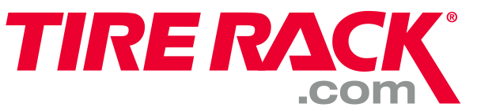
Damage option (A) Defect options (B) Aged (C)
Option Choices Option Choices Provide the Full DOT for each different date
1. Bead 5. Bead
2. Tread 6. Tread DNC (D)
3. Sidewall 7. Sidewall Please Provide the full description and full DOT
4. Liner/Foam 8. Liner/Foam Example: 235/60R18 Hercules Avalanche RT DOTU94E1K32923

100 International Drive Windsor, CT 06095
1-800-428-8355 EXT:4854
DC Manager – Pierce Highfill
Ext 4599 – EM: phighfill@tirerack.com

Date:________________
Supplier / Vendor: ______________________
ASN / PO #: ______________________
Printed Name (First, Last):______________

Note Carriers BOL with the Description of any Damages, Shorts and Over when signing out the driver!

ISSUE TYPE: SHORT (S) /OVER (O) / DAMAGED (A) /DEFECT (B)/ AGED (C) /DNC (D)

Issue Qty Vendor # Size Brand Model Speed Rating Option # DOT/EXPLANTION ASN
Load Index Return

Y / N

Y / N

Y / N

Y / N

Y / N

Y / N

Y / N

Y / N

Y / N

Y / N

Y / N

